Regression Test Script
Company | PCUBE

Request No / Project Name
Title / Description | SIT for Marketing Campaign process
Created by / Date | 11/07/2024

Test Plan & Person in Charge

Description | Effort in Man days | Person In charge | Planned Schedule
Description | Effort in Man days | Person In charge | Start Date | End Date
Data Preparation | 1 | Ankit/Deepthi | 10/07/2024 | 11/07/2024
Regression Testing | 1 | Ankit/Deepthi | 10/07/2024 | 11/07/2024
Go Live

Scope & Scenario

Scope
Create a new DP campaign for sales campaign and promotions for Marketing users.
Test Scenarios
Scenario #1: | Marketing user create New Campaign for Hero Banner.  Logged in as Elise TAN user  https://p-cube--fulluat.sandbox.lightning.force.com/lightning/r/Campaign/701H1000000cNRcIAM/view  create a new Sales Campaign of type Hero Banner Content.  - Open the Campaigns tab  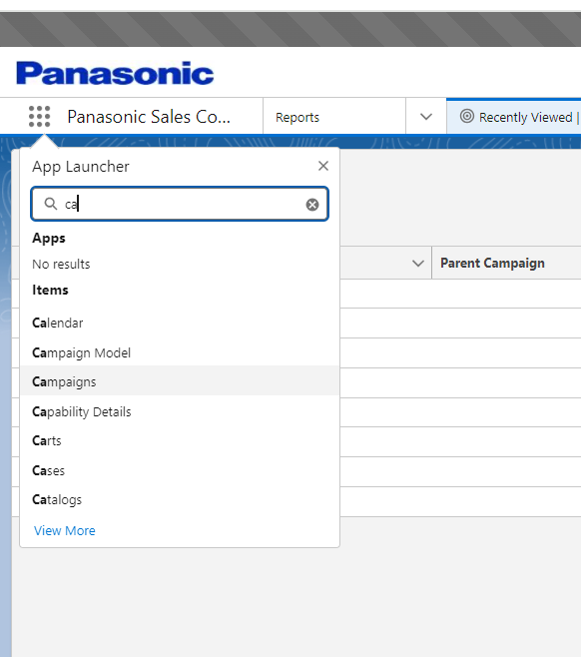  - Click on the New button  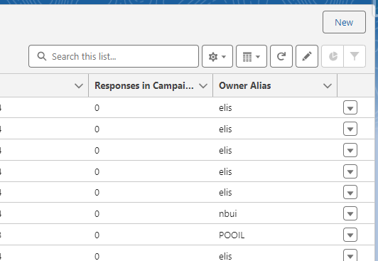  - fill the mentioned information  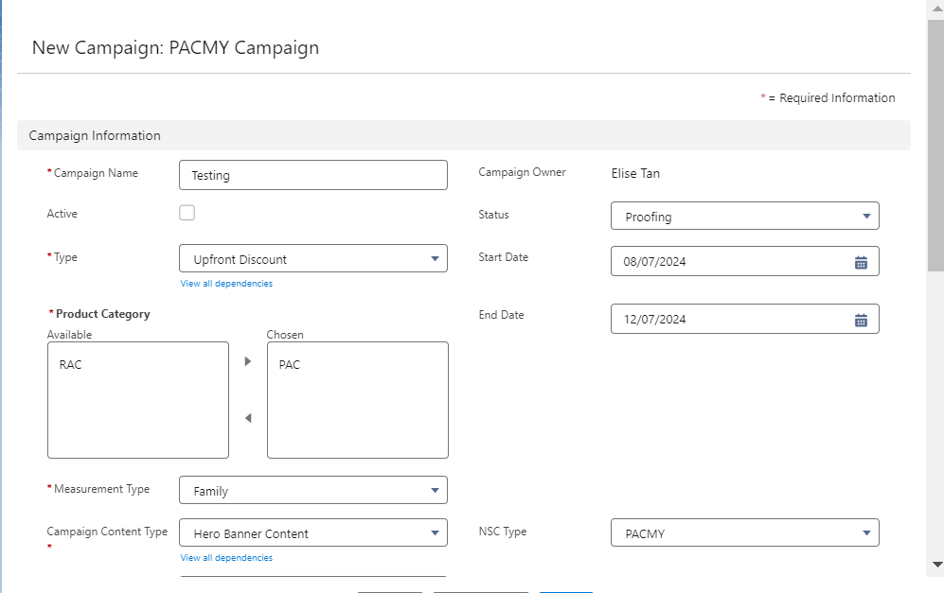  - & 5.fill the mentioned information  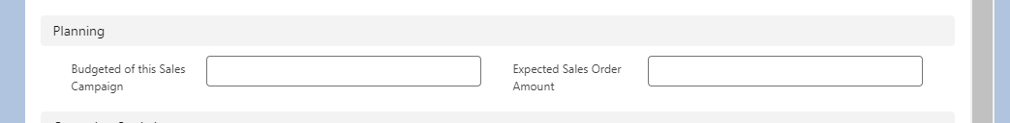  6.Click on the Save button  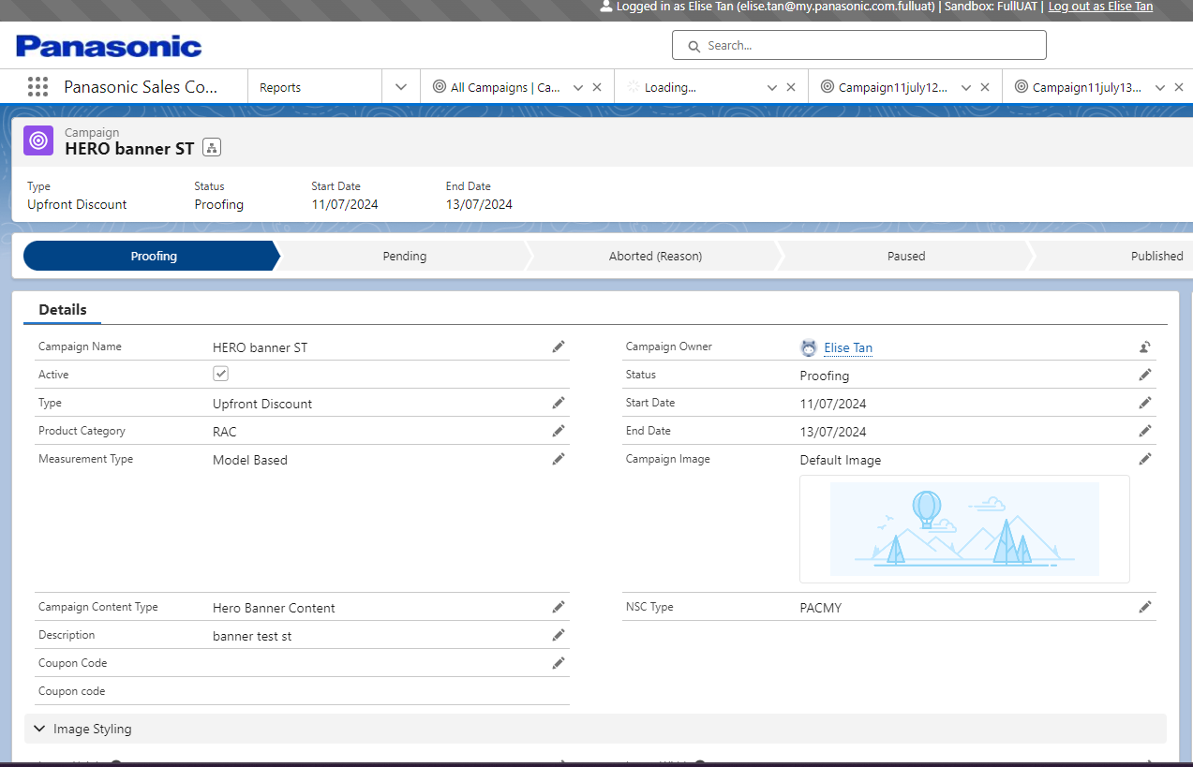  Scenario #2:  Marketing user create New Campaign for Promotion Tile  create a new Sales Campaign of type Sales Promotion Tile Content  - Open the Campaigns tab  - Click on the New button  - fill the mentioned information  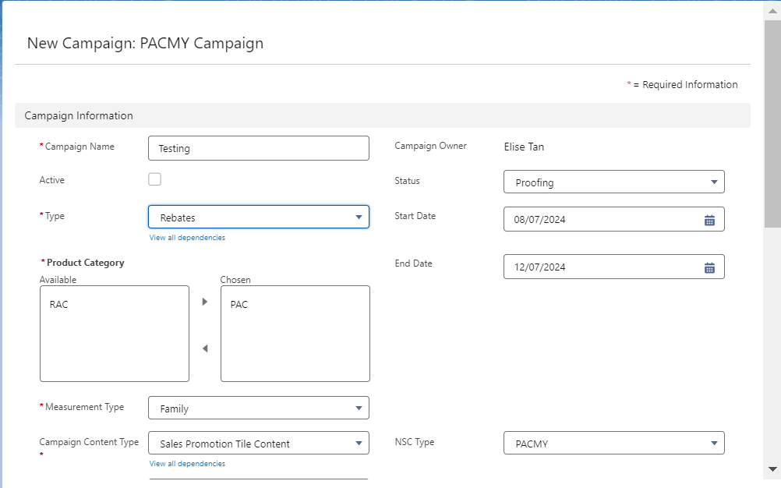  - 4 &5 fill the mentioned information  - Click on the Save button  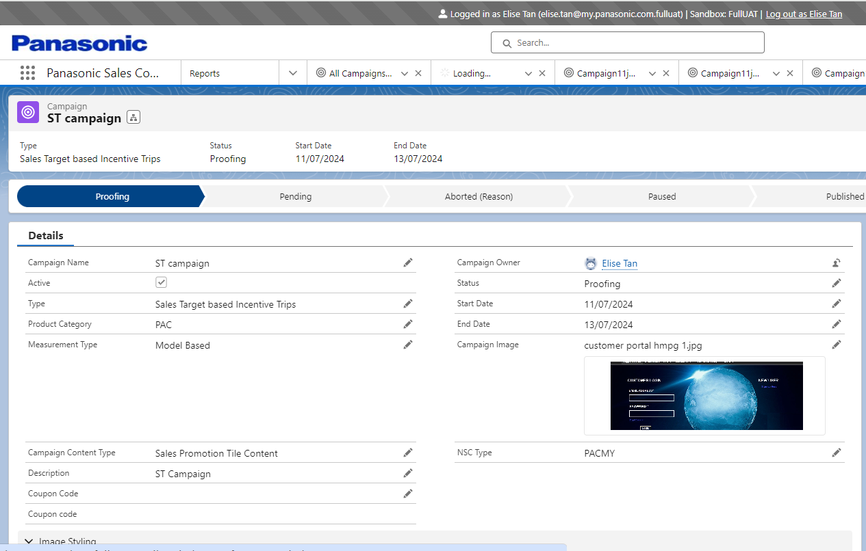  Scenario #3:  Marketing user to view Campaign details  user can view the fields and related lists of a newly created Campaign record.  - Go to Campaign tab  - Open the Campaign list view  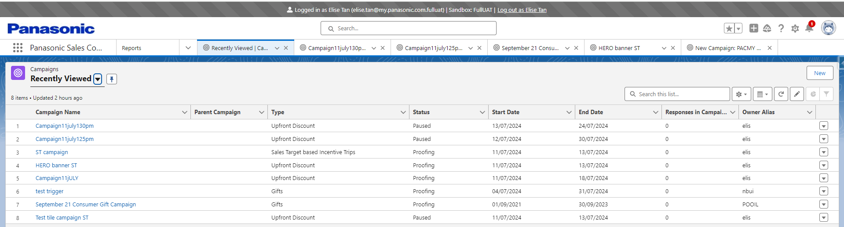  - Click on a specific sale campaign  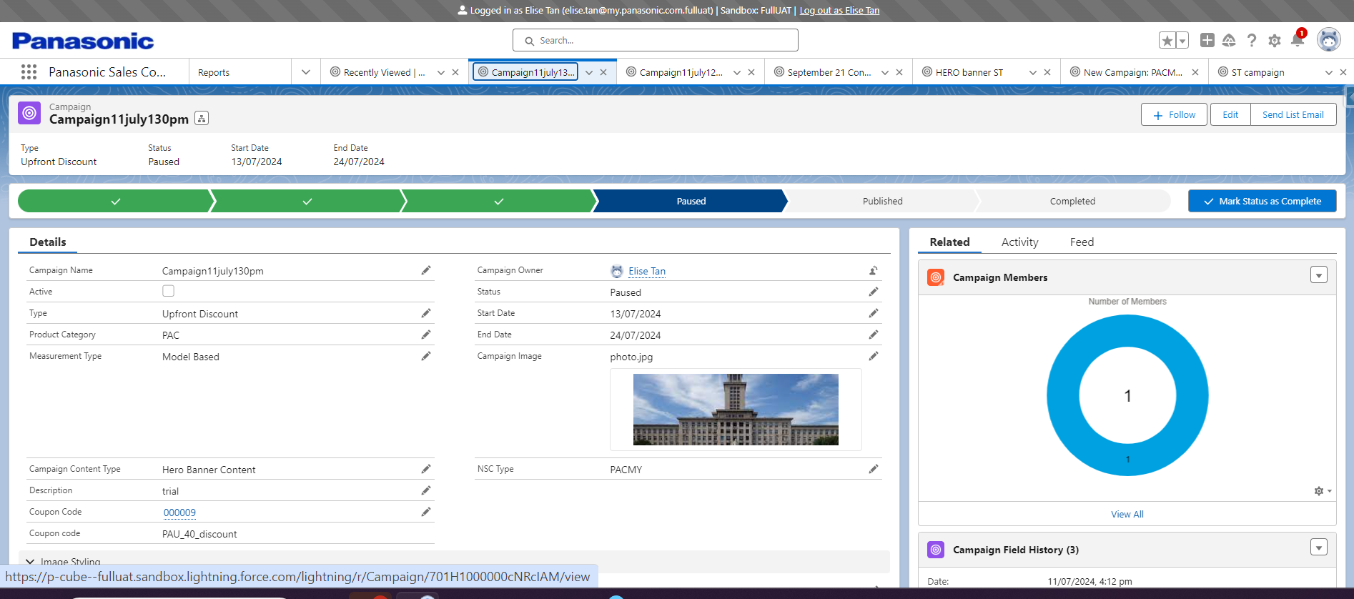  - Validate that on header a path is visible with mentioned values:  Proofing > Pending > Published > Completed > Paused > Aborted (Reason)  - Validate on the cards are visible:  > Campaign Header Bar  > Related Lists Tab  > Activity Tab  - Go to Related tab.  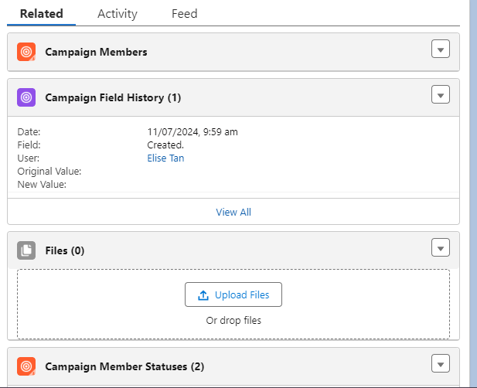  - Validate that mentioned related tabs are visible:  Campaign Members  Files  Campaign Member Statuses  Notes  Campaign Products  Approval History  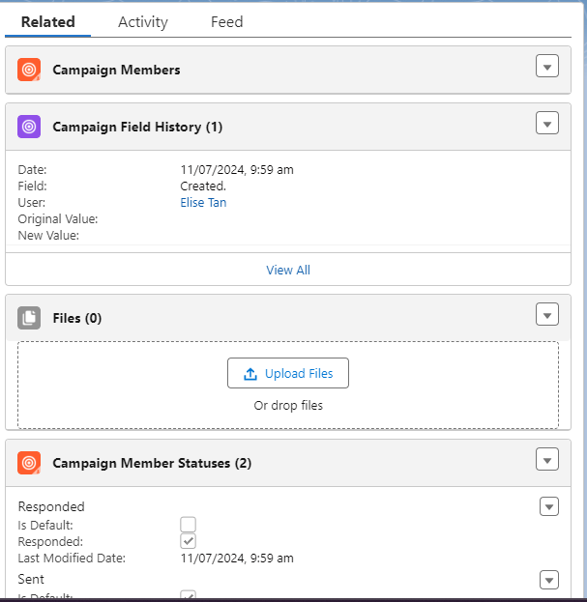  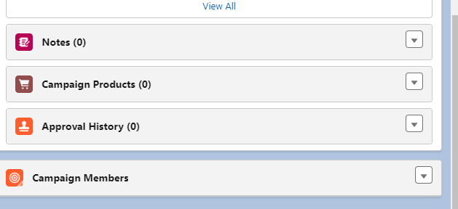  - Go to Activity tab  - Validate that mentioned subtabs are visible  > Log A Call  > New Task  > New Event"  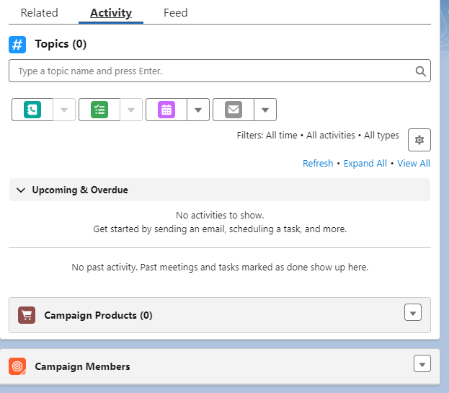  Scenario# 4:  Add product to Campaign  user can add and manage products as part of the Sales Campaign  - Go to Campaign tab  - Open the Campaign list view  - Click on a specific sales campaign  - Go to Related tab.  - View the Campaign Related Products related list  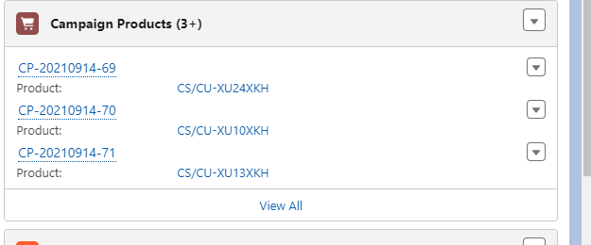  - Click on Add Products button in top right corner of the Campaigns record  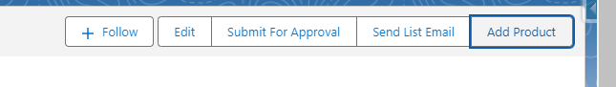  - Without Searching/Selecting any Product, click on Submit button  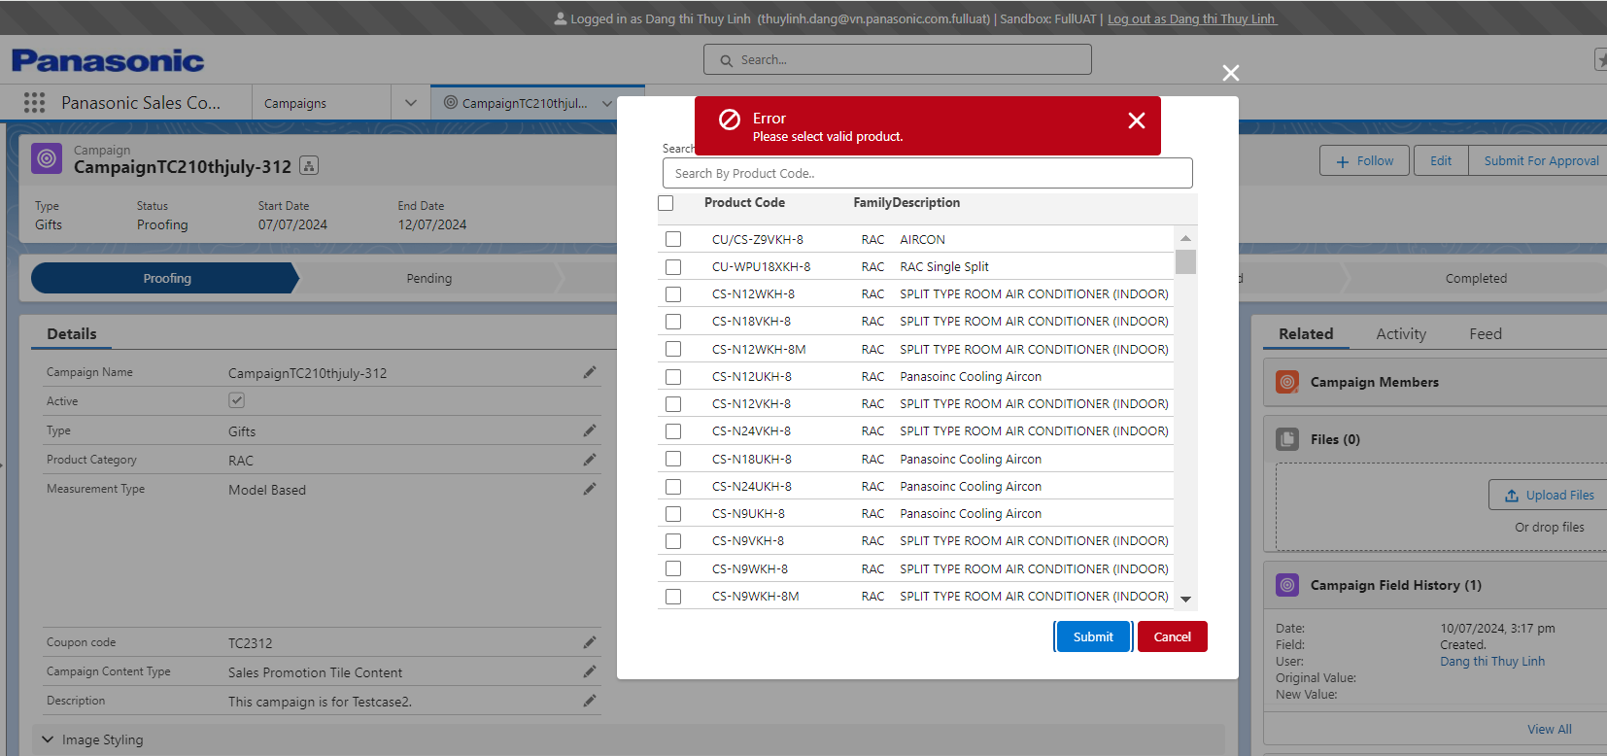  - Click on the Search box and check if the Products listed.  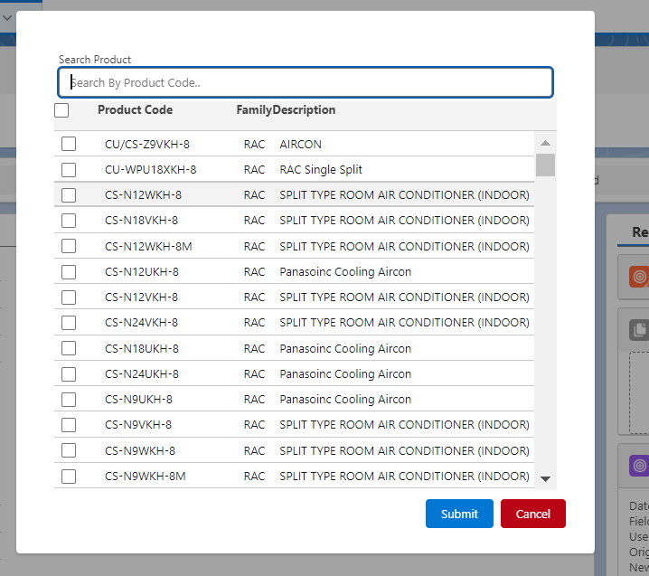  - Search for a Product within the Category, set at the Campaign details level/ Select a Product from the Product list displayed below the search textbox.  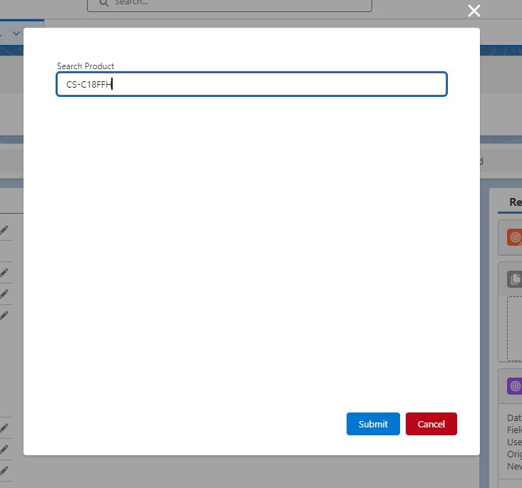  - Click Submit button  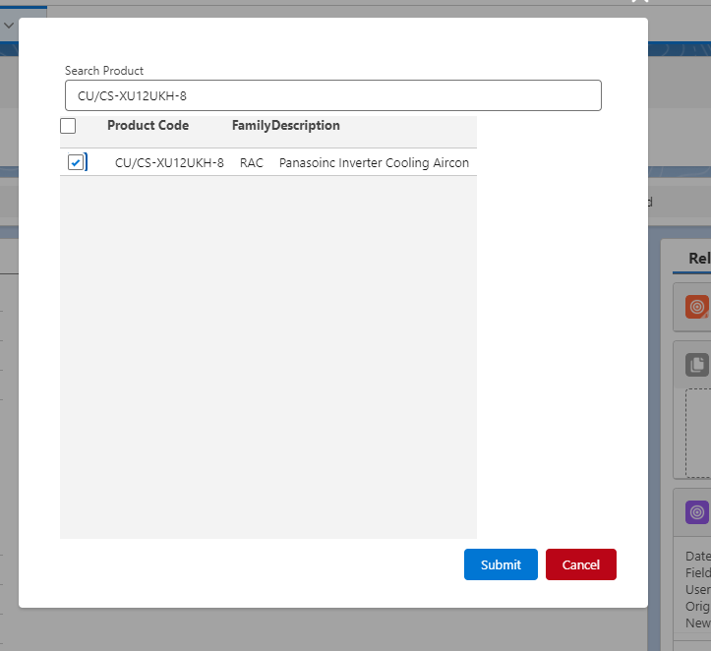  - Navigate to the Campaign Products related list and check if the newly added Product in Step 10 is listed  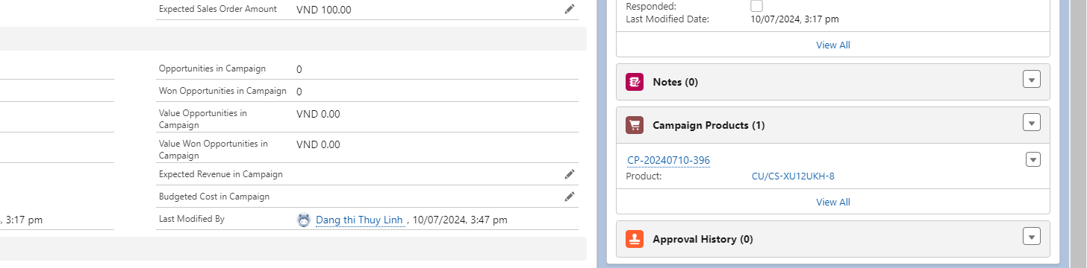  - Search for a Product NOT within the Category, set at the Campaign details level.  - Click Submit button  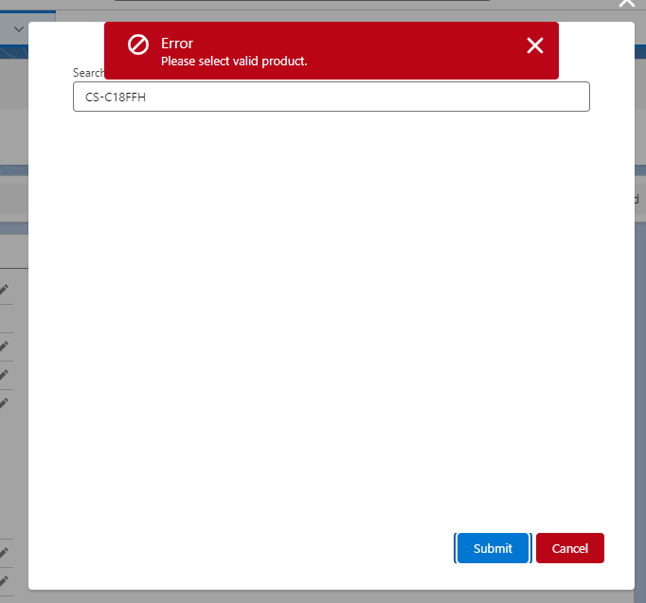  Scenario # 5  Add member to campaign  user is able to add and manage members to their campaign  - Go to Campaign tab  - Open the Campaign list view  - Click on a specific sales campaign  - Go to Related tab.  - Scroll to Campaign Members related list  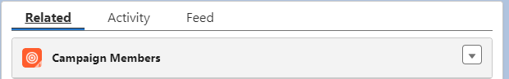  - Click on the 'Add Contacts' button  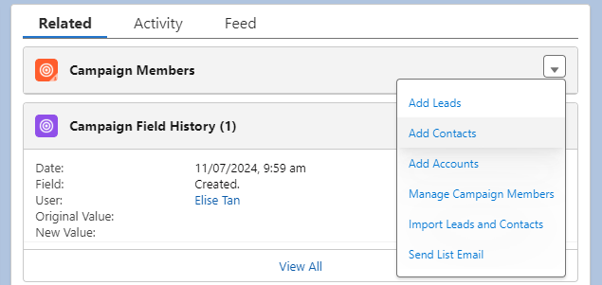  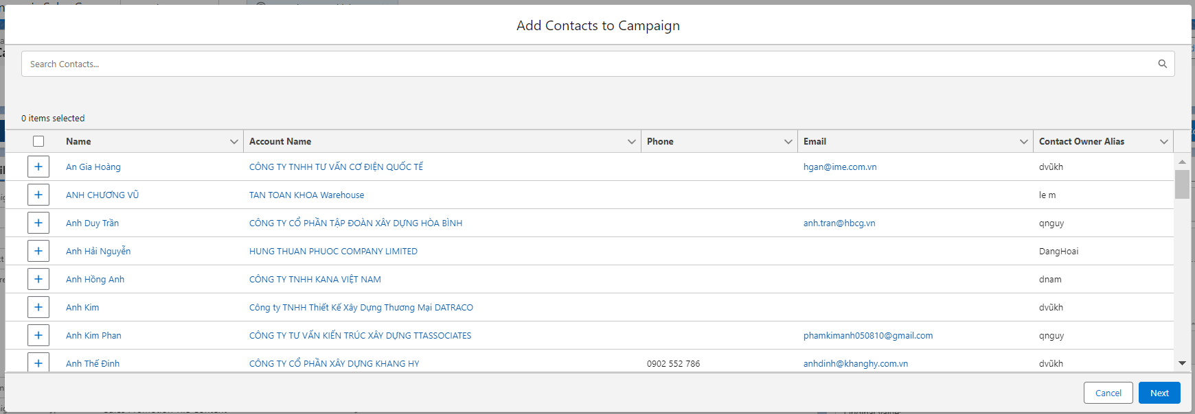  - Click on the select all button to add the entire list of dealers as members  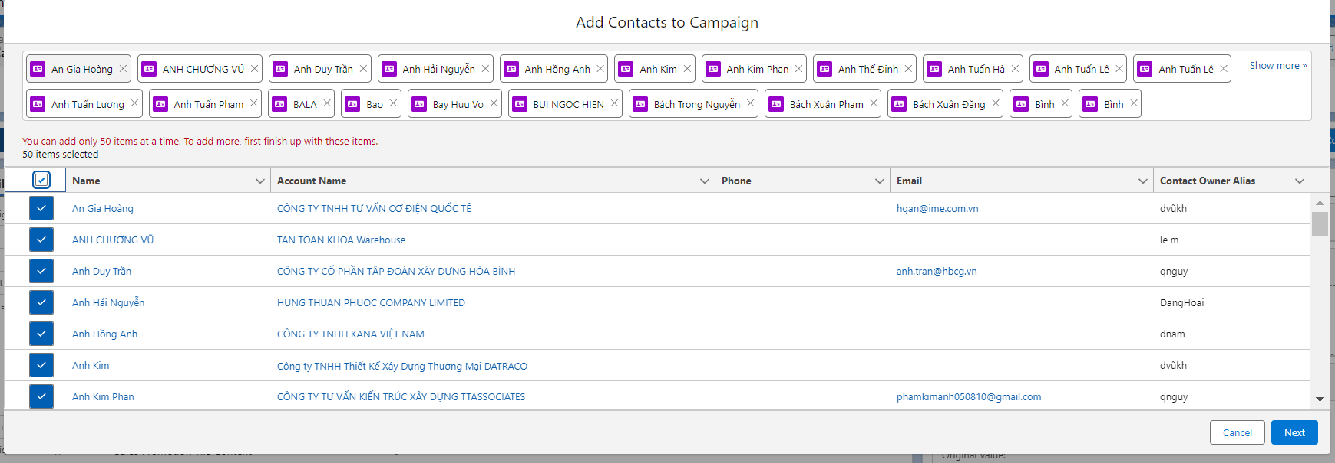  - Click on Save button  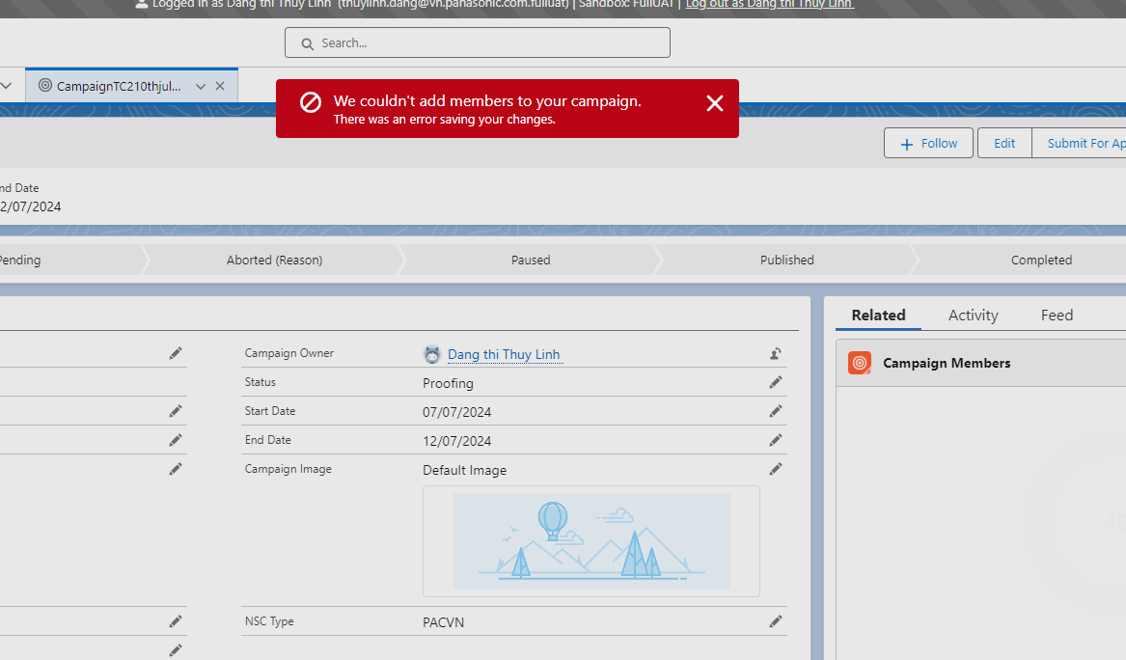  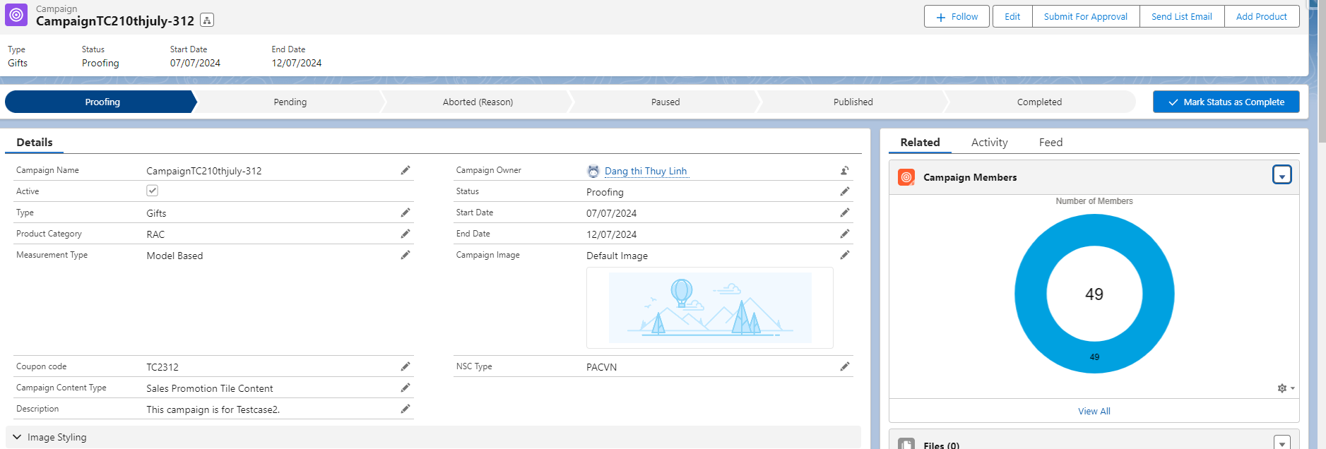  Scenario # 6  Add Circular PDF to campaign  user can upload the A4 Circular PDF and is able to send it out as a mass email to members of the Sales Campaign  - Go to Campaign tab  - Open the Campaign list view  - Click on a specific sales campaign  - Go to Related tab.  - Scroll down to Files related list  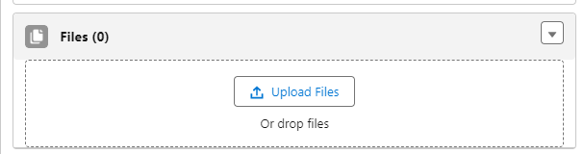  - Drag and drop the PDF document into the upload files field  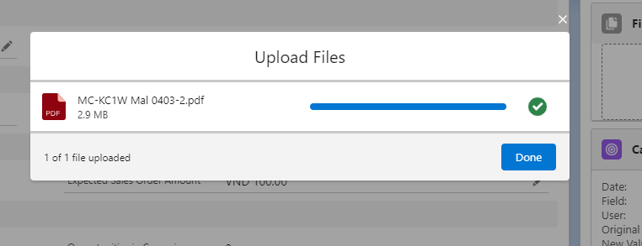  - Wait till the upload is complete and click Done  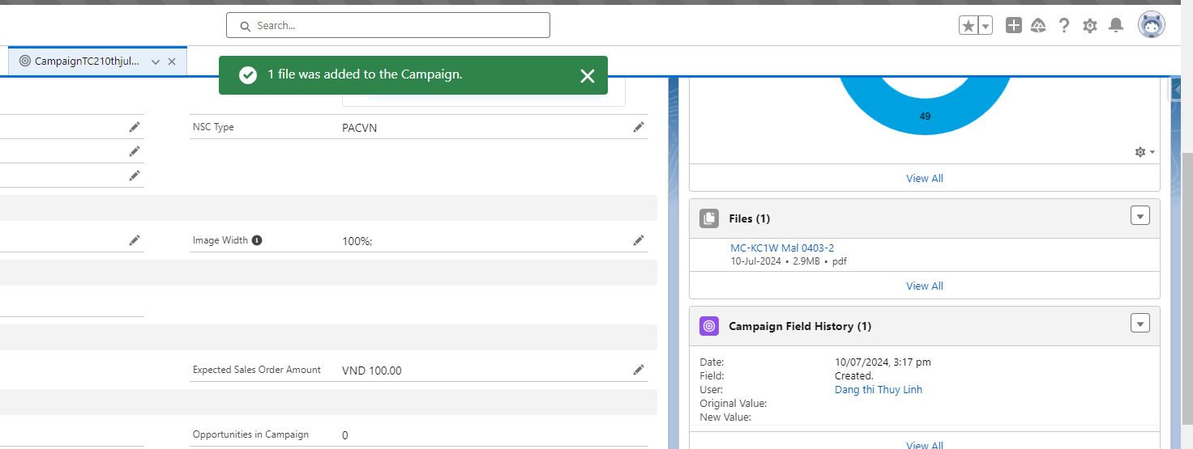  - Validate that thumbnail of the uploaded file is visible in the related list for retrieval later  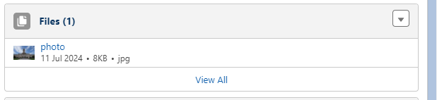  - Go to the Activity tab and then to the Email subtab  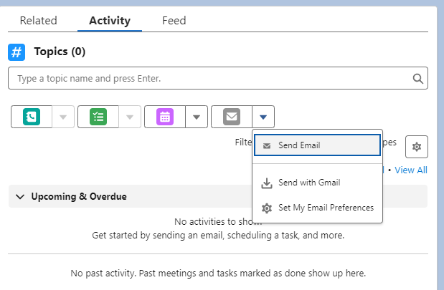  - Fill all the details and attach the file.In the To field add the Email ID of Sales Team and Campaign Members.  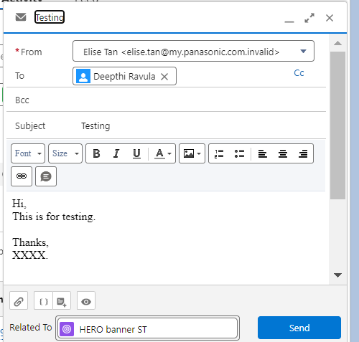  - Click on Send button  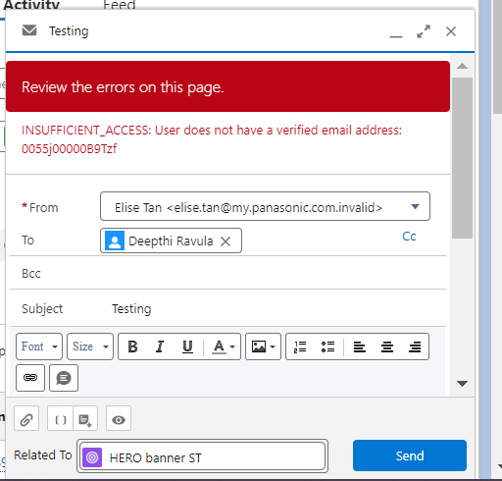  Scenario # 7  B2B2C-SC-006A-MY  user can create a Discount Coupon to be used on for the promotion.  - Go to CC Coupons Field  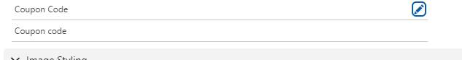  - Click on "+New CC Coupon”.  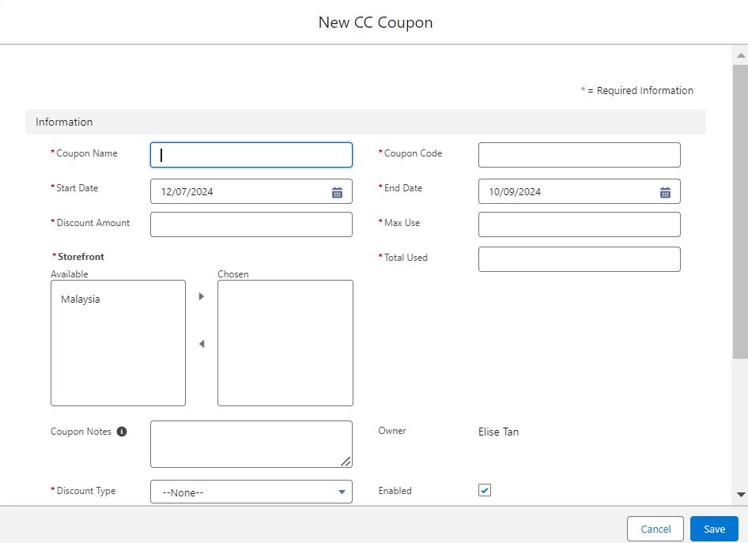  - Fill mentioned details:  > Coupon Name  > Coupon Code  > Start Date  > End Date  > Rule Type  > Discount Type  > Discount Amount  > Max Use  > Total Used  > Storefront (MY or VN)  > Minimum Quantity  > Coupon Notes  > Owner  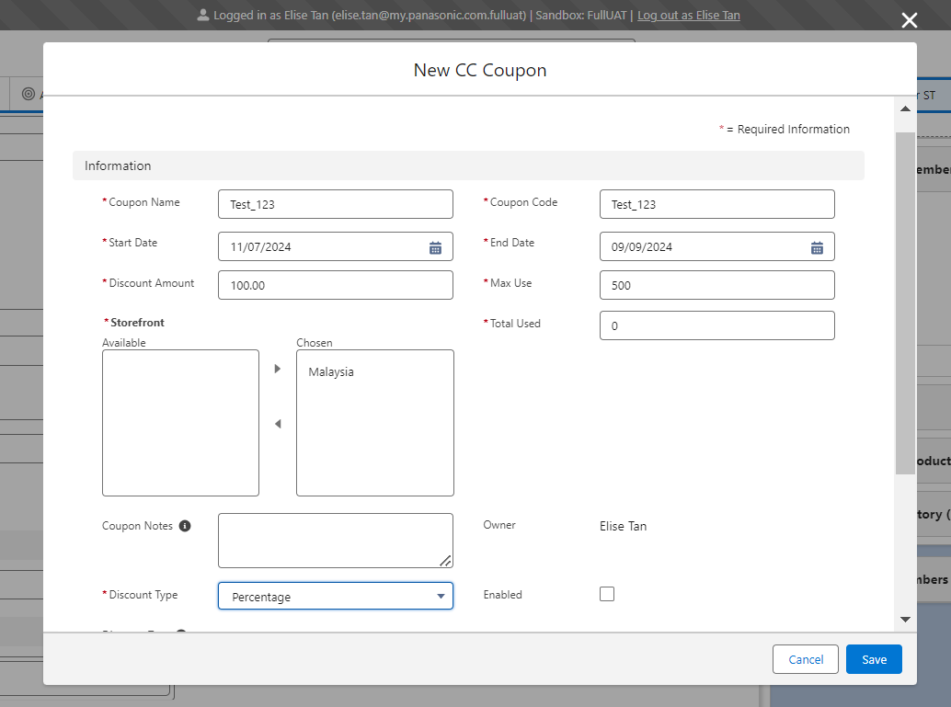  - Click on Save button  Scenario # 8  Submit campaign for approval.  user can submit this Sales Campaign to Marketing Management.  - Go to Campaign tab  - Open the Campaign list view  - Click on a specific sales campaign  - Click on the 'Submit for Approval' button  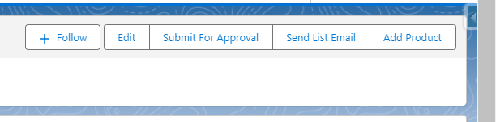  - In the Campaign Deatils page -> Navigate to the Approval List section -> Select a Marketing Team Lead user in the "Marketing Team Lead" lookup  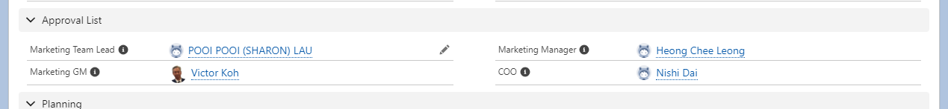  - Click on the 'Submit for Approval' button  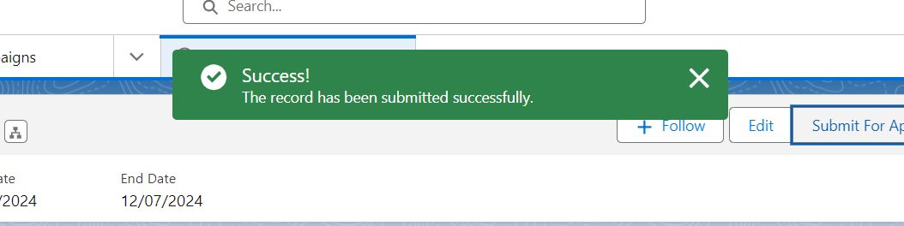  - Confirm that the approver listed is correct  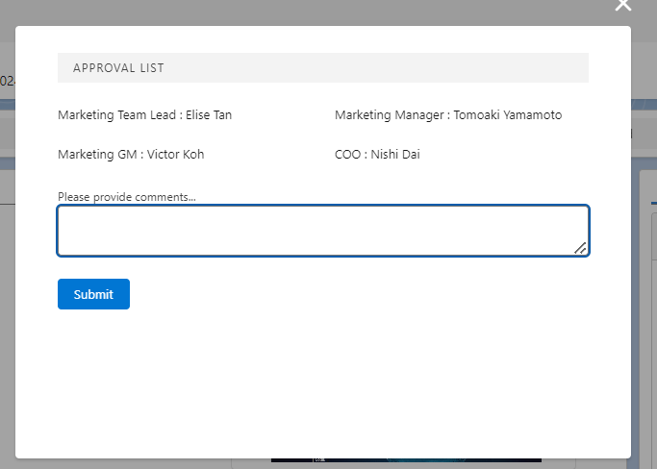  - Add comments if needed  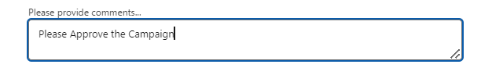  - Click on Send button  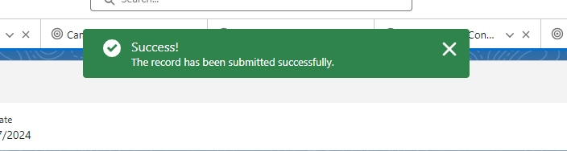  Scenario # 9  Campaign approval by Marketing Team Lead  Logged in as Elise Tan user should able approve/reject the campaign record.  - Open Salesforce org  - Click on the bell icon present in right corner  - Observe the notification related to campaign approval request and click on it  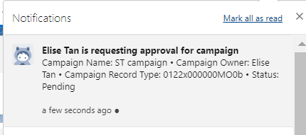  - Validate that Campaign record details are visible  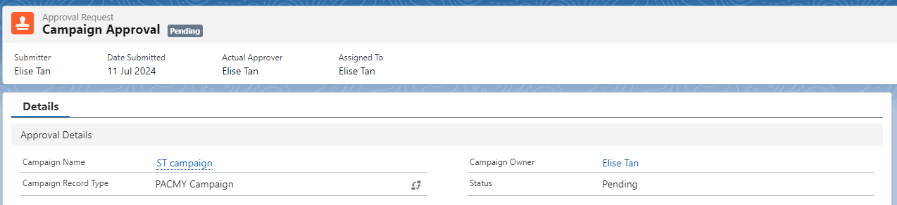  - Go to Related tab and scroll down to Approval History related list  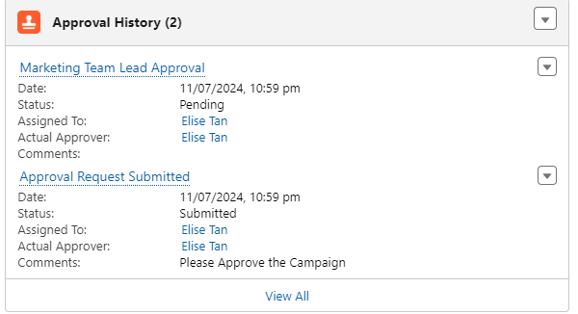  - To Approve, click on Approve button.  Enter the comments  Click on Approve button  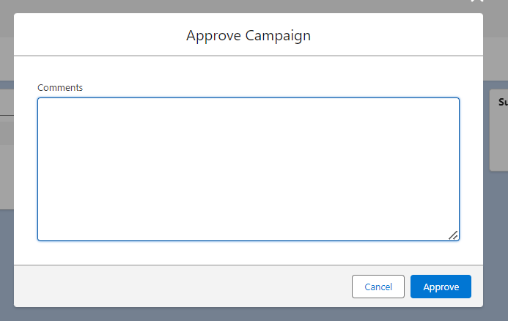  - To Reject, click on Reject button  Enter the comments  Click on Reject button  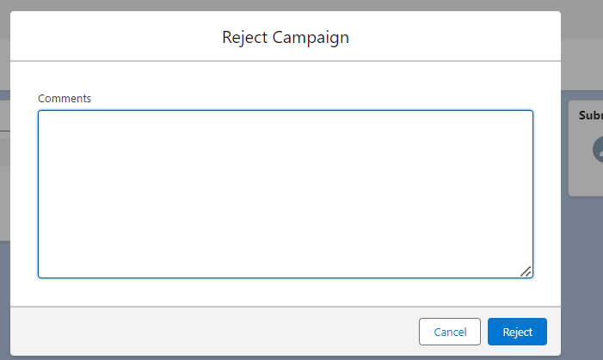  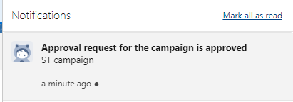  Scenario # 10  Campaign approval by Marketing Manager  Logged in as Tomoaki Yamamoto user should able approve/reject the campaign record.  - Open Salesforce org  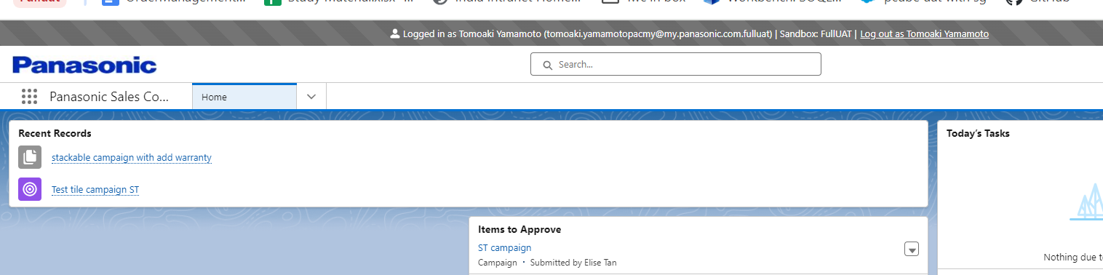  - Click on the bell icon present in right corner  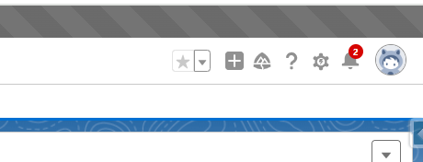  - Observe the notification related to campaign approval request and click on it  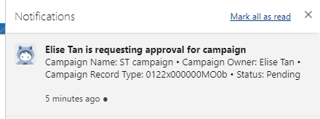  - Validate that Campaign record details are visible  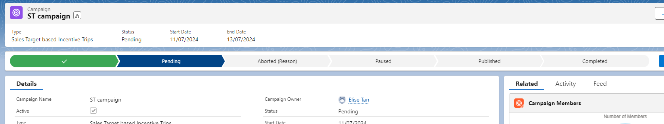  - Go to Related tab and scroll down to Approval History related list  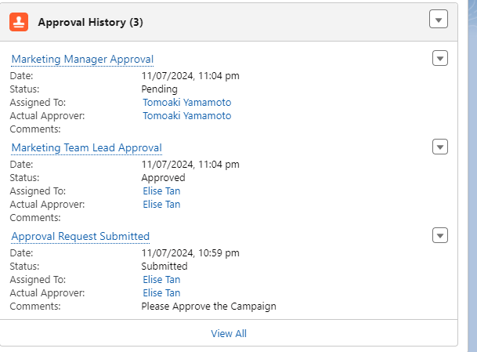  - To Approve, click on Approve button.  Enter the comments  Click on Approve button  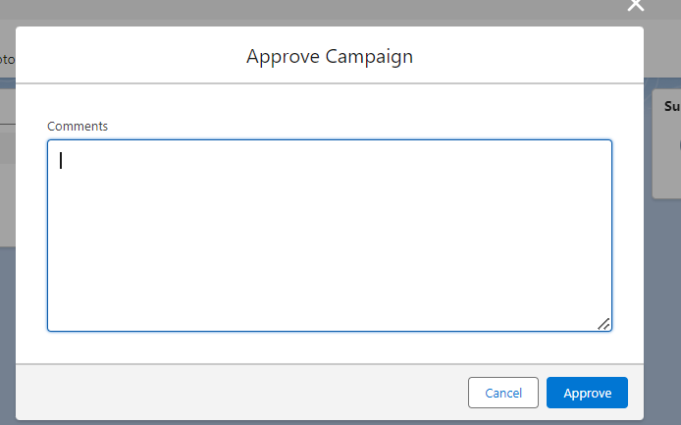  - To Reject, click on Reject button  Enter the comments  Click on Reject button  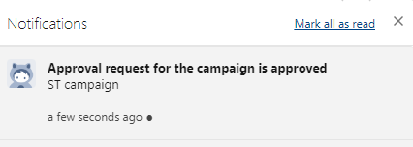  Campaign approval by Marketing GM  Scenario # 11  Logged in Victor Koh as user should able approve/reject the campaign record.  - 1. Open Salesforce org  - Click on the bell icon present in right corner  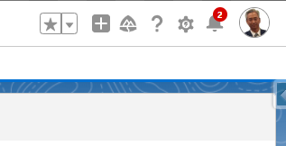  - Observe the notification related to campaign approval request and click on it  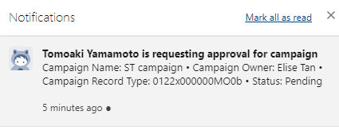  - Validate that Campaign record details are visible  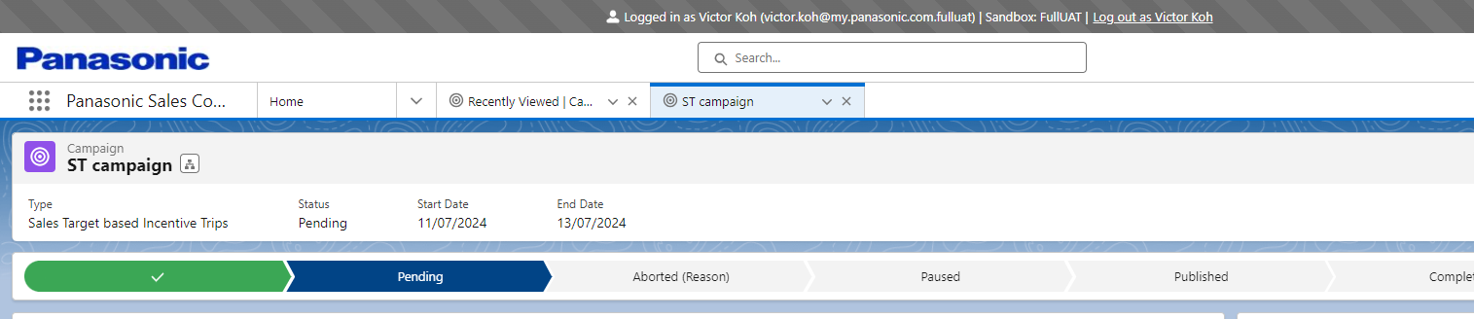  - Go to Related tab and scroll down to Approval History related list  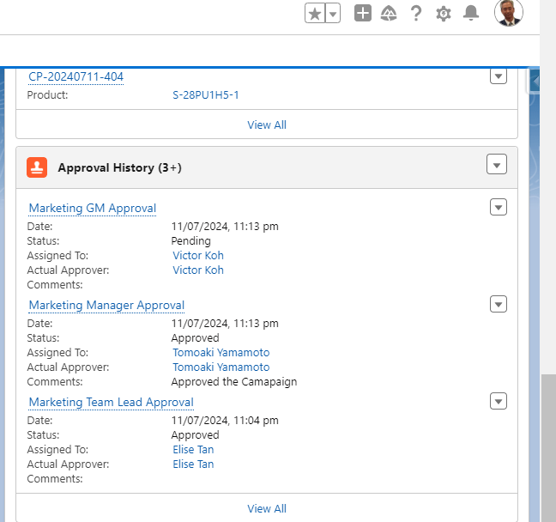  - To Approve, click on Approve button.  Enter the comments  Click on Approve button  - To Reject, click on Reject button  Enter the comments  Click on Reject button  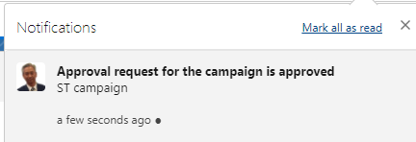  Scenario # 12  Campaign approval by coo  Logged in as Nishi Dai user should able approve/reject the campaign record.  - Open Salesforce org  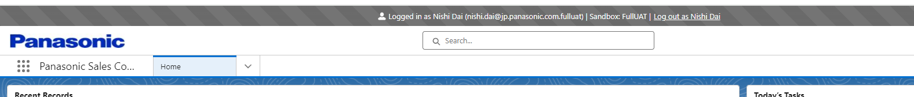  - Click on the bell icon present in right corner  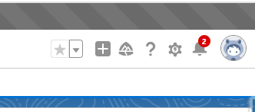  - Observe the notification related to campaign approval request and click on it  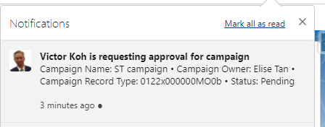  - Validate that Campaign record details are visible  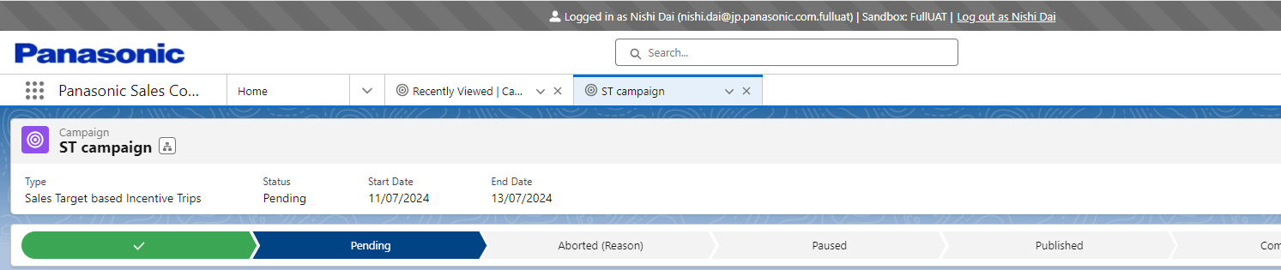  - Go to Related tab and scroll down to Approval History related list  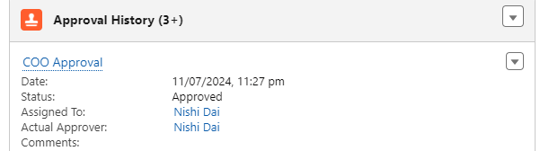  - To Approve, click on Approve button.  Enter the comments  Click on Approve button  - To Reject, click on Reject button  Enter the comments  Click on Reject button  - Validate that on approval, the status of the campaign record is getting updated to Published.  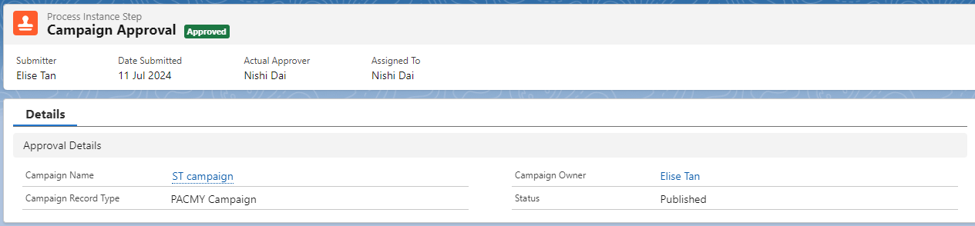  Scenario # 13  Dealer portal view Campaign  user is able to view Campaigns and Promotions from dealer portal  Logged in as Dealer portal:  https://p-cube--fulluat.sandbox.lightning.force.com/lightning/r/Contact/0032x00000GnUYHAA3/view?ws=%2Flightning%2Fr%2FAccount%2F0012x00000LNhgyAAD%2Fview  - Click on "Campaigns and Promotions" from menu bar  - Validate that mentioned tabs are visible:  Campaign Marketplace  All Campaigns  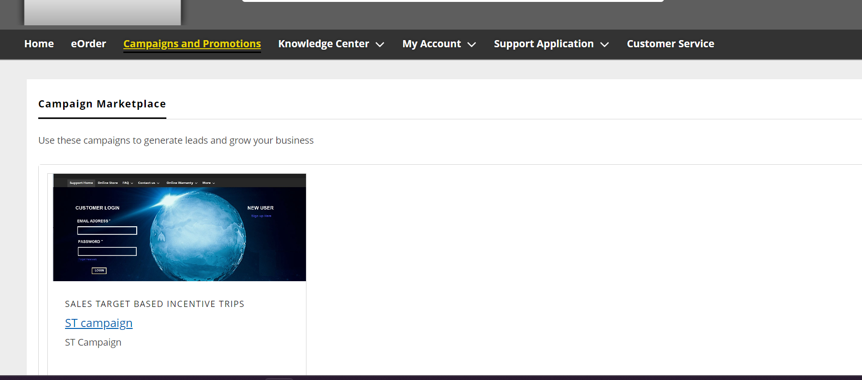  - On Campaign Marketplace tab, validate that all Home screen campaign and promotion records are visible here.  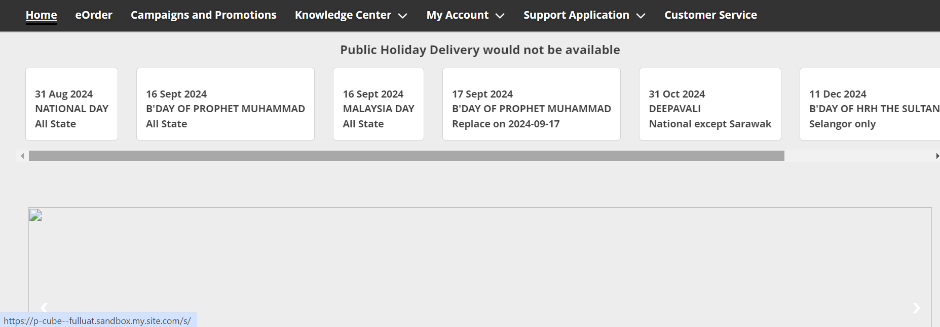  - Click on any Campaign Name to open it  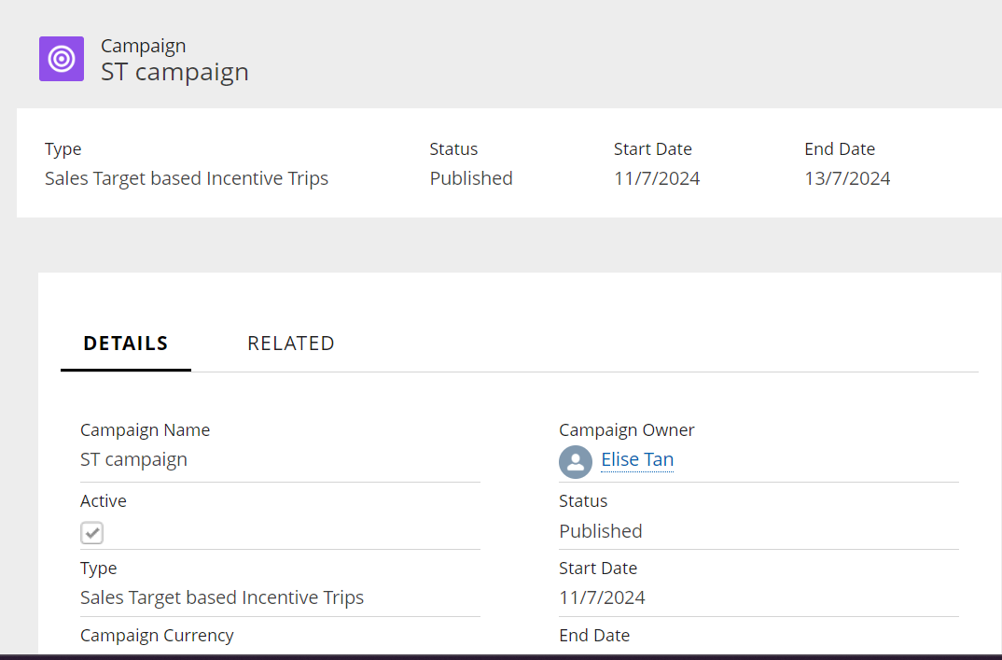  - Validate that mentioned details are visible on Details tab:  Campagin Name  Type  Status  Start Date  End Date  Campaign Image  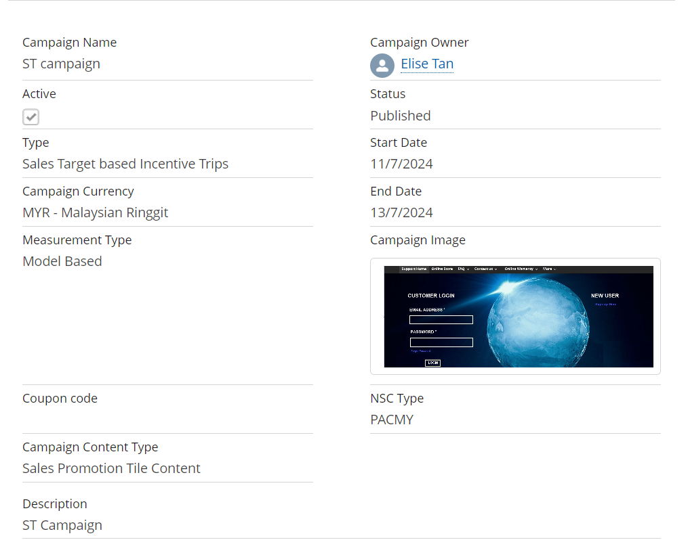  - Validate that Post panel is visible.  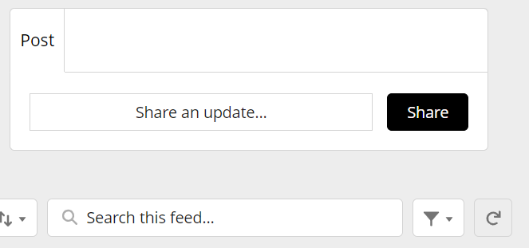  - Type the updates and click on Share button.  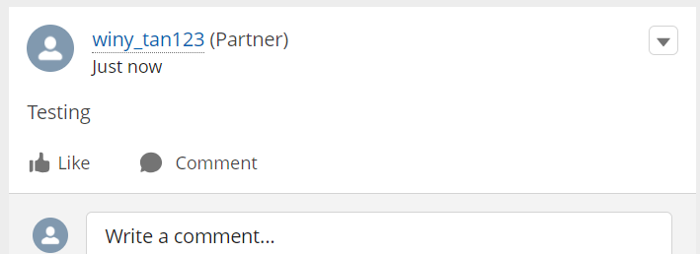  Scenario # 14  Pause campaign.  user can pause the Sales Campaign  1. Go to Campaign tab  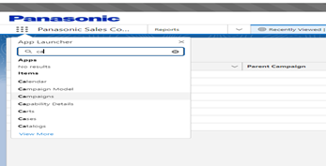  2. Open the Campaign list view  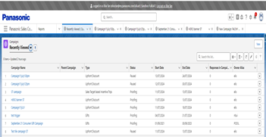  3. Click on a specific sales campaign  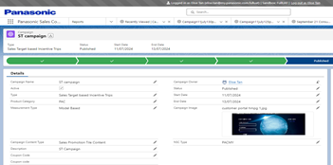  4. From the Path, select the Pause status.  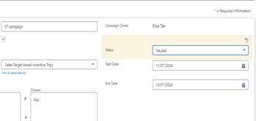  5. Click on Mark as Current Status button  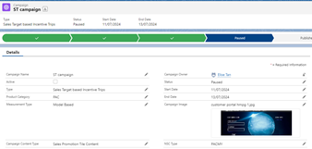  6. Validate that all coupon codes associated with the campaign are automatically deactivated.  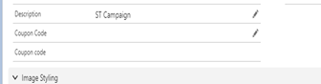  7. Validate that all related sales campaign promotion content are unpublished from the dealer portal  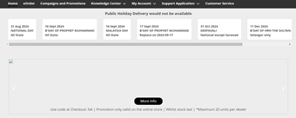  8. Validate that campaign had stop attributing sales orders to the sales campaign amount.  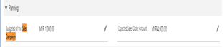

_________________________________________________________________________________________________________________________
_________________________________________________________________________________________________________________________

Regression Sign off.

 | Tested By  [Business Unit] | Verified By  [Business Unit] | Endorsed By  [PISCAP IT] | Acknowledge of SOX Compliance
Name | Ankit/Deepthi | Diviya | Sasitar | - Above changes are compliant with SOX regulations.
Role Title | Consultant | SFDC AMS Team Lead | IT support | - Above changes are compliant with SOX regulations.
Department | AMS team | SFDC AMS | Salesforce team | - Above changes are compliant with SOX regulations.
Signature | Ankit  Deepthi | diviya | Sasitar | - Above changes are compliant with SOX regulations.
Date | 11/07/2024 | 3/07/2024 | 2/07/2024 | - Above changes are compliant with SOX regulations.

